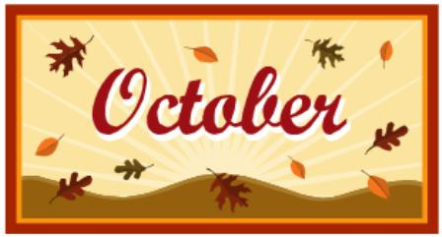* Breakfast Grade School and High School
Monday | Tuesday | Wednesday | Thursday | Friday
This Institution Is an Equal Opportunity Provider |  |  | 1  Muffins  Milk  Juice | 2  PB&J Crustables  Fruit  Milk  Juice
5  Pop Tarts  Milk  Juice  High School  Cereal Bars | 6  Yogurt  Cheese Stick  Milk  Juice  High School  Breakfast Burritos | 7  Sausage Biscuits  Milk  Juice  High School  Sausage egg & Cheese Biscuits | 8  PB&J Crustables  Milk  Juice | 9  No  School
12  Pop Tarts  Milk  Juice  High School  Cereal Bars | 13  Yogurt  Cheese Stick  Milk  Juice  High School  Breakfast Burritos | 14  Sausage Biscuits  Milk  Juice  High School  Sausage egg & Cheese Biscuits | 15  PB&J Crustables  Milk  Juice | 16  Fall Break
19  Fall Break | 20  Pop Tarts  Milk  Juice  High School  Cereal Bars | 21  Sausage Biscuits  Milk  Juice  High School  Sausage egg & Cheese Biscuits | 22  Muffins  Milk  Juice | 23  PB&J Crustables  Fruit  Milk  Juice
26  Pop Tarts  Milk  Juice  High School  Cereal Bars | 27  Yogurt  Cheese Stick  Milk  Juice  High School  Breakfast Burritos | 28  Sausage Biscuits  Milk  Juice  High School  Sausage egg & Cheese Biscuits | 29  Muffins  Milk  Juice | 30  PB&J Crustables  Fruit  Milk  Juice

